**CST2107 Final Exam/Project**

Author: Tao Yang, student# 040926874

Quick reference to create EC2 instance:

1. Name and tags

voclabs/user2160491=**yang0256**

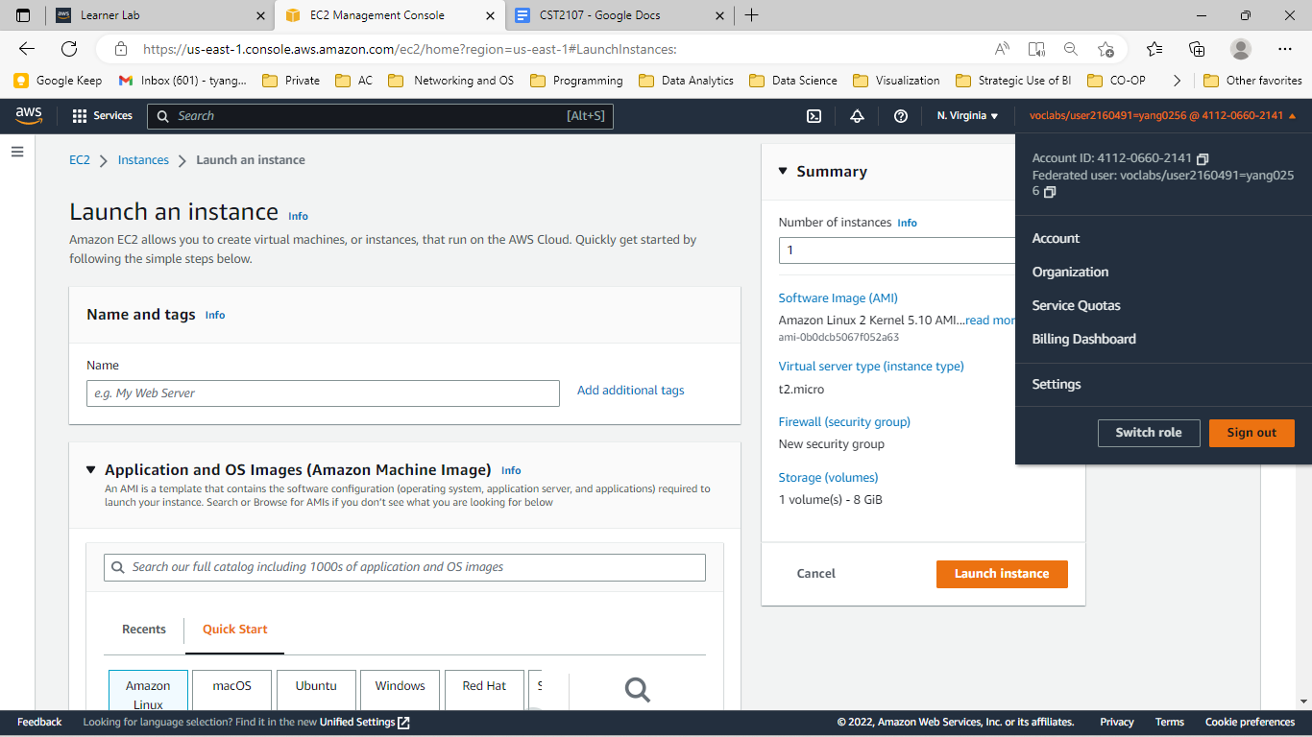

2. Application and OS Images (Amazon Machine Image)

* Services> EC2 > Instances > Launch Instance

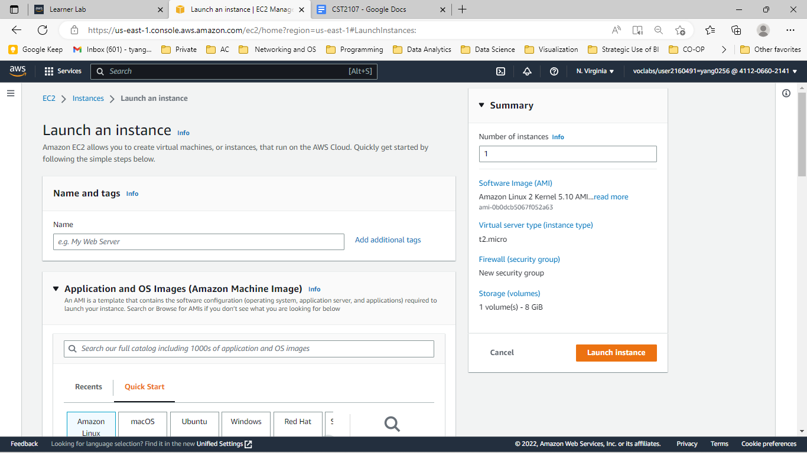

* or Create a new launch template

Create Launch template, type “Windows_Launch_tpl” in Launch template and description “windows_2022_plus”.

By creating a new template, giving a name and description, it will save time in creating new instances with the same settings in the future.

3. Instance Type

Select “Microsoft Windows Server 2022 Base” from catalog and picked “t2.large” , which is good for 8G memory and 2 vCPU. Here to choose list of Linux and windows server OS, and /or applications pre-built with OS. don’t need to install the app later.

4. Key pair (login)

Choose to create a new Key pair, pop up window asking for Key pair name. Enter “MyNewKeyPair”, click the radio button to reflect your private key. Choose .ppk if you use Putty. After hit Create key Pair, MyNewKeyPair.pem is downloaded to my laptop.

This private key is for client verification to use establish connection to the new Windows server.

5. Network settings

IP address 172.31.48.xxx/20 will be assigned to this server after the instance is initiated, and this IP address is private. To configure a static address. Please refer to the later section on the Elastic IP address configuration.

Security

Inbound tcp traffic: enable TCP port 3389 for RDP into Windows server and 1433 for Database access

Assign Elastic IP address:

Public IP address 35.169.137.129 is assigned.

Services> EC2> Network & Security > Elastic IPs > Actions> Allocate Elastic IP address

Associate the assigned elastic IP address to the new created instance

Associate the public ip address to instance and NAT to private IP address 172.31.50.10

Static public IP 34.227.196.170 is configured on the instance.

RDP login Windows Server 2022 and add new admin user “Winprof” and password

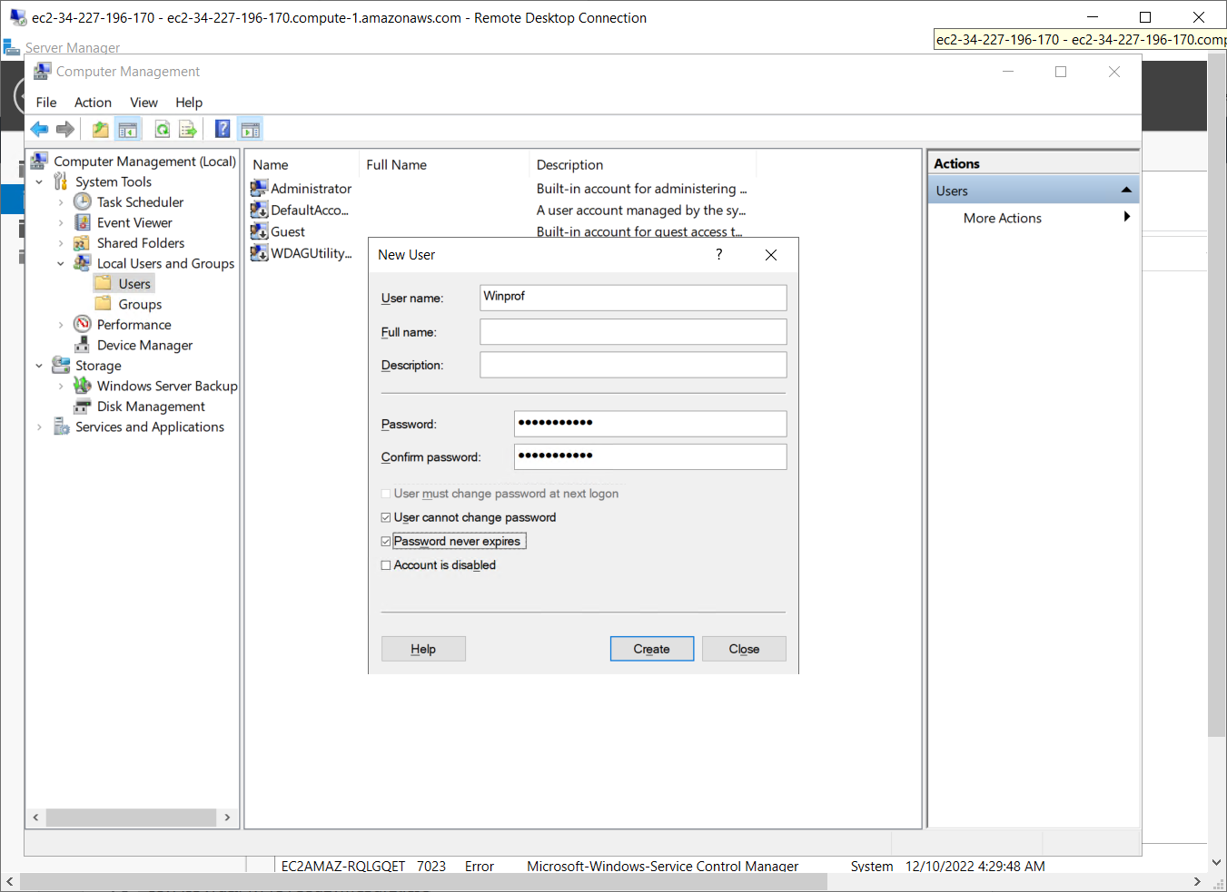

Tested new RDP remote access with new username: “Winprof” and the password “Education1!”

6. Configure Storage

Storage 30G is good for this lab project.

7. Advanced details

Advanced instance settings that user can choose:

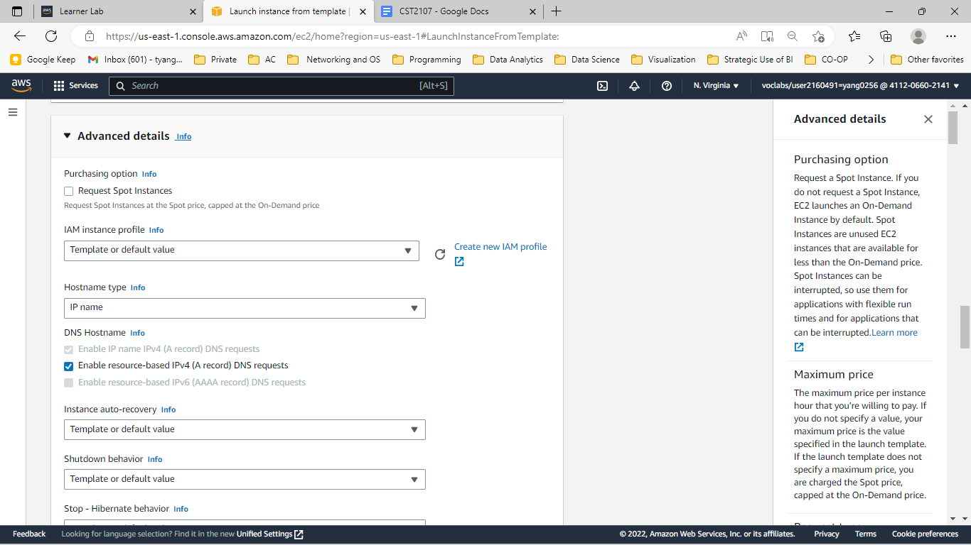

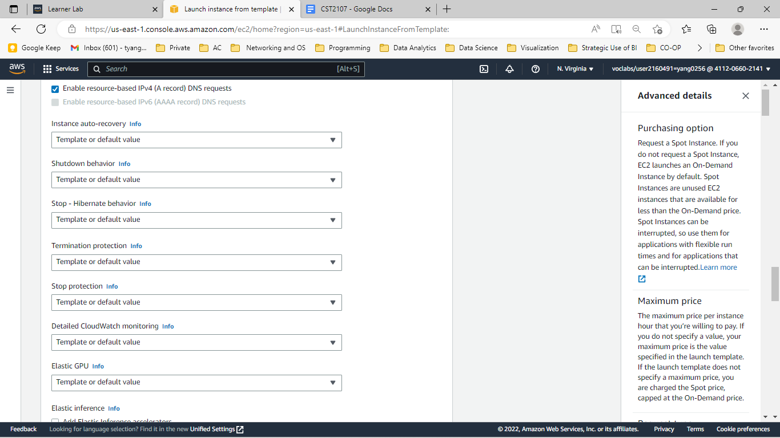

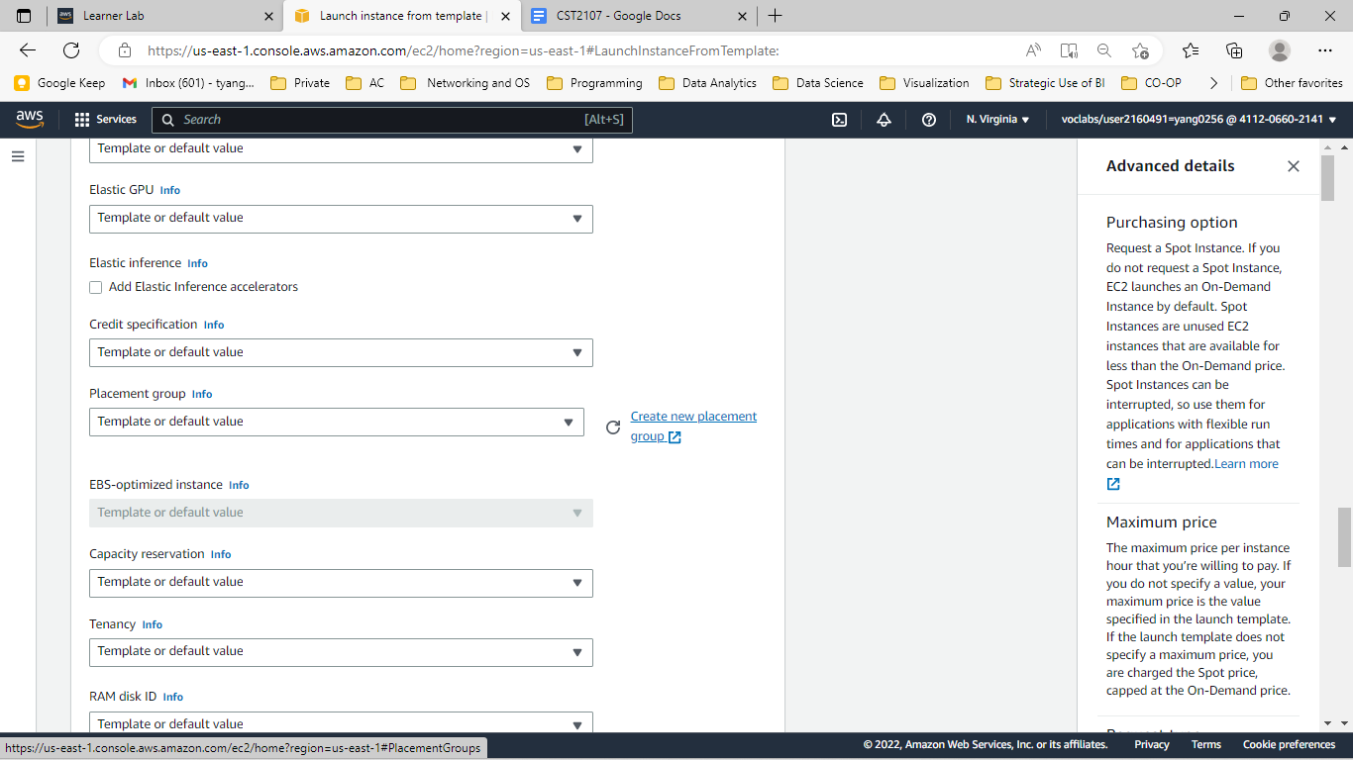

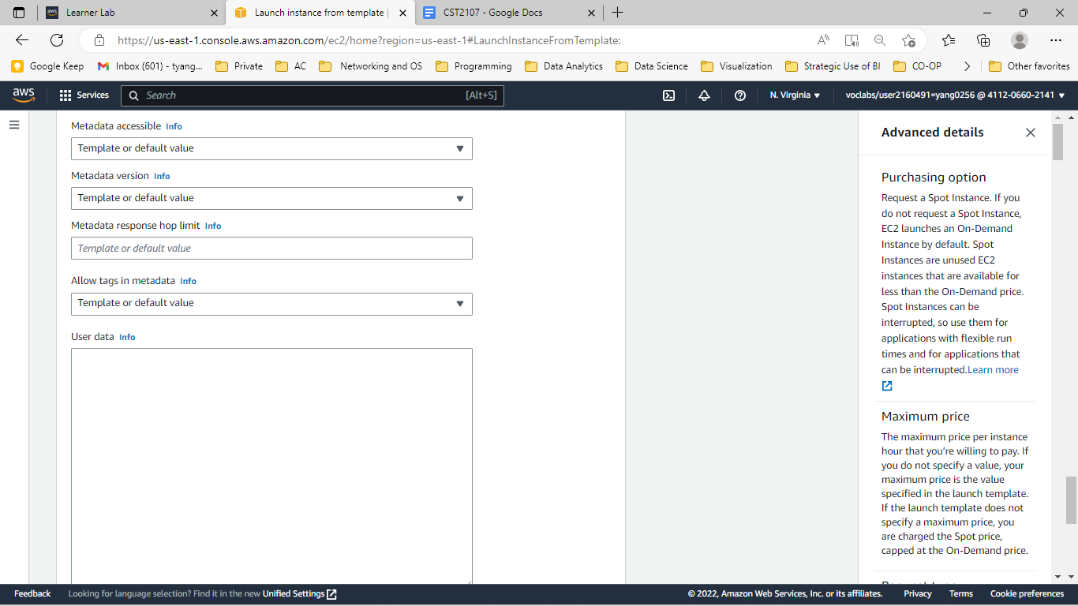

8. Summary

